COURSE/WORKSHOP

TRAVEL AND ACCOMODATION

ISLE OF WIGHT

Cross Solent Ferry Services
If travelling to the Isle of Wight from you will need to use one of the ferry services to get here. There are a number of choices for both foot passengers, cars, caravans and freight. Ferry services run from Lymington, Southampton and Portsmouth.

Hovertravel
Hovertravel run hovercraft services between Ryde Esplanade and Southsea in under 10 minutes. They have a frequent service running 7 days a week for foot passengers. Full information on getting to the Southsea Hoverport is available on their website.

Red Funnel Services
Red Funnel runs services over 2 routes to and from the Island.
- Red Jet Hi-Speed: Southampton to West Cowes (passenger only). Runs every 30 minutes throughout the day, journey time approx. 23 minutes.
- Passenger/Vehicle Ferry: (Southampton to East Cowes). Operates 24 hours a day, journey time approx. one hour.
Both services connect to a free bus service from Southampton Central Rail Station. Full details of getting to the Red Funnel terminals are available on their website.

Wightlink Services
Wightlink runs services over three routes to and from the Island.
- Portsmouth to Ryde Pier Head (Fast Cat Passenger Service). Journey time approx. 22 minutes.
- Portsmouth to Fishbourne (Car and Passenger Service). Journey time approx. 40 minutes.
- Lymington to Yarmouth (Car and Passenger Service). Journey time approx. 30 minutes.

Getting Around the Island

We can arrange to pick you up from a ferry terminal if required. To get around whilst you are here there are other transport options on the Isle of Wight. This includes good road coverage, bus and train public transport services and at only approximately 25 miles by 13 there are good travel options through cycling and walking.

Public Transport
Bus services on the Island are provided by Southern Vectis. Full information is available at www.islandbuses.info. There are over 20 standards routes serving the majority of the island as well as having good connections to the main ferry terminals.
Island Line Trains (part of the South West Trains group) operate a train service between Ryde Pier Head (connecting with the WightLink fastcat) and Shanklin. Full details can be found at www.southwesttrains.co.uk/island-line.aspx

Travel by Car
All major towns are connected by a network of A-roads. Typical travel times as an example from Newport, the central town on the Island are:
- Newport - Sandown approx. 20 mins.
- Newport - Ryde approx. 20 mins.
- Newport - East Cowes approx. 15 mins.
- Newport - Freshwater approx. 25 mins.
General advice would be to avoid the main towns during busy / commuting times. Latest road works information is available on the Isle of Wight Council website.

Cycling
The many quiet countryside roads on the island make it very good for cycling. As well as the roads the is a considerable network of designated cycle tracks and routes as well as miles of public bridleways for those who like off road cycling. We have two ‘Boris Bikes’ you are welcome to use free of charge.
Current established cycle routes include Cowes to Newport, Sandown to Newport, Wotton to Newport and Yarmouth to Freshwater as well as a shorter route connecting Newport to the Mountbatten Centre. More details on the cycle routes can be found at www.visitisleofwight.co.uk/things-to-do/cycling
There is also a well sign posted 'Round the island' road route which can be easily followed by those wanting to cycle right round the Island.

Walking
The Isle of Wight has a wealth of footpaths and bridleways and is reputed to have more footpaths per square mile than any other English county - from a 60 mile coastal path, to easy circular routes, and short town trails - there are over 500 miles of well-maintained paths on an island that measures 23 by 15 miles
The Coastal Path can be walked in four days at a leisurely pace. The coastline is varied from white chalk cliffs to quiet estuaries. Almost half of the coastline is designated "Heritage Coast", a definition applied only to coastlines of the highest quality and unspoilt nature.
Inland the chalk down lands are the home to many unique wild flowers and fauna, and the Island has some of the most picturesque villages in the country.
There is good information on walking routes and activities www.visitisleofwight.co.uk/things-to-do/walking

Courses are held in the beautiful quaint village of Brighstone on the West coast of the island – go to http://www.brighstoneparish.org/ for more detail.

This is the beach just ten minutes’ walk from the centre of Brighstone village. 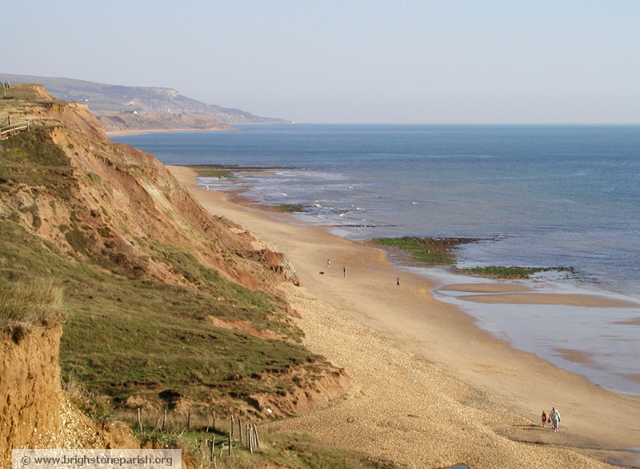

Accommodation
Please go to http://www.brighstoneparish.org/visitor-information/places-to-stay/ for details of local accommodation including camping.

Please check on Trip Advisor before booking any of the venues listed.

Places of Interest
The Isle of Wight has many places of interest to suit all hobbies and tastes. For information about what is available right across the island go to:

http://www.visitisleofwight.co.uk/explore/places-to-visit

Local Places to Eat and Drink
There is a wide range of restaurants, cafes and bars right across the island which because it is a small island means most of them is reachable. However, if you want something local to where the course is taking place then go to:
http://www.brighstoneparish.org/visitor-information/places-to-eat-drink/

For any further information please don’t hesitate to contact us and we will endeavour to do our best to help.

